Architectures for Software Systems
Present structures of software Architecture
Reading Questions 5
Nguyễn Sĩ Hiền – K14T01 – T086828
Readings:
[Clement 02] Prologue, chapter 3, 4

Questions:

- Establish style guide for C&C View type
Answer:
- First to Establish style guide for C&C View type, we need understands what is C&C View type. C&C view type is treated as first class design element in architecture. C&C views are commonly used in practice, and indeed, box-and-line diagrams depicting these views are often the graphical medium of choice as a principal first-look explanation of the architecture of a system. Then, this is example about C&C view type
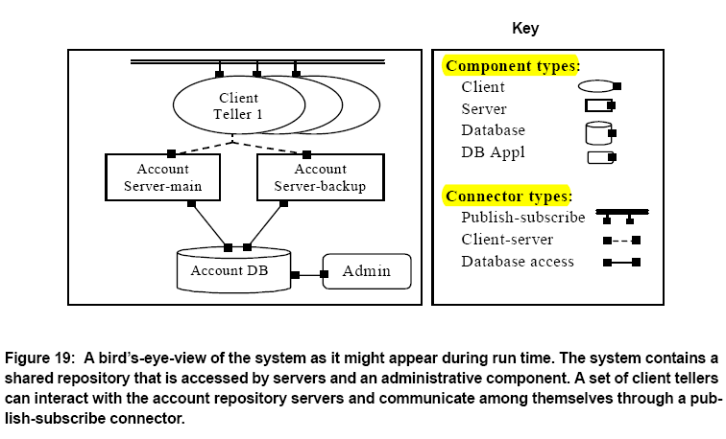
- To design C&C View Type, we need identify clearly include elements, relations, properties of element, topology and this is table which describe them.

Elements | Components: principal processing units and data stores  Connectors: interaction mechanisms
Relations | Attachments: define system topology by indicating which component ports are associated with which connector roles
Properties of element | Component:  - Name -- component name should hint at its functionality  - Type -- defines general functionality, number and types of ports, required properties  - Ports -- a list of ports and their types and/or properties  - Other properties -- depend on type of component, but include things such as performance and reliability values.  Connector:  - Name -- connector name should hint at the nature of its interactions  - Type -- defines nature of interaction, number and types of roles, required properties  - Roles -- a list of roles and their properties  - Other properties -- depend on the type of connector, but include things such as protocol of interaction, and performance values
Topology | Ports may only be attached to roles
- C&C viewtype is for :
  - Component-and-connector views are commonly used to show developers and other stakeholders how the system works. The C&C views (with associated behavior documentation) specify the structure and behavior of the runtime elements.
  - Component-and-connector views are also used to reason about runtime system quality attributes, such as performance, reliability, and availability. In particular, a well-documented view allows architects to predict overall system properties, given estimates or measurements of properties of the individual elements and interactions.
- Notation for C&C view :
  - Informal : As always, box-and-line drawings are available to represent C&C views ( look like Figure 19 )
  - Formal: using UML to represent C&C views.
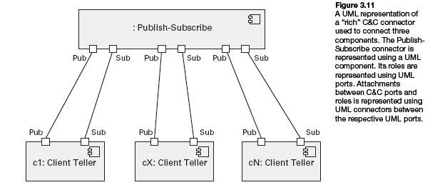

- List all styles of C&C View type. Each team member will be assigned one different style and establish style guide for that style.
Answer:
- C&C viewtype include four common style: ( follow Documenting software architecture 2010 )
  - Data Flow Style
    - The Pipe-Filter Style
  - Call-Return Style
    - Client-Sever Style
    - Peer-to-Peer Style
    - Service-Oriented Architecture style
  - Event-Based Styles
    - Publish-Subscribe Style
  - Repository Styles
    - Shared-Data Style
- And then, I will represent about Pipe-and-Filter Style
  - Overview: The pattern of interaction in the pipe-and-filter style is characterized by successive transformations of streams of data. Data arrives at a filter’s input ports, is transformed, and then is passed via its output ports through a pipe to the next filter. A single filter can consume from, or produce data to, multiple ports.
  - Element, relationship, computational Model, constraints, and what it’s for
Elements | - Filter, which is a component that transforms data read on its input ports to data written on its output ports. Filters typically execute concurrently and incrementally. Properties may specify processing rates, input/output data formats, and the transformation executed by the filter  - Pipe, which is a connector that conveys data from a filter’s output ports to another filter’s input ports. A pipe has a single data-in and a single data-out role, preserves the sequence of data items, and does not alter the data passing through. Properties may specify buffer size, protocol of interaction, and data format that passes through a pipe.
Relations | - The attachment relation associates filter output ports with data-in roles of a pipe, and filter input ports with data-out roles of pipes.
Computation Model | - Data is transformed from a system’s external inputs to its external outputs through a series of transformations performed by its filters.
Constraints | - Pipes connect filter output ports to filter input ports.  - Connected filters must agree on the type of data being passed along the connecting pipe.  - Specializations of the style may restrict the association of components to an acyclic graph or a linear sequence—sometimes called a pipeline.  - Other specializations may prescribe that components have certain named ports, such as the stdin, stdout, and stderr ports of UNIX filters.
What it’s for | - Improving reuse due to the independence of filters  - Improving throughput with parallelization of data processing  - Simplifying reasoning about overall behavior

- Publish-subscribe, client-server, and call-and-return styles all involve interactions between producers and consumers of data or services. If an architect is not careful when using one of these styles, he or she will produce a C&C view that simply shows a request flowing in one direction and a response flowing in the other. What means are at the architect's disposal to distinguish among these three styles?
Answer:
- Call-return styles embody a computational model in which components provide a set of services that may be invoked by other components. A component invoking a service pauses (or is blocked) until that service has completed. Hence, call return is the architectural analog of a procedure call in programming languages. The connectors are responsible for conveying the service request from the requester to the provider and for returning any results.
- As with all call-return styles, client-server style components interact by requesting services of other components. Requesters are termed clients, and service providers are termed servers, which provide a set of services through one or more of their ports. Some components may act as both clients and servers. The client-server style presents a system view that separates client applications from the services they use. This style supports system understanding and reuse by factoring out common services
- Components may subscribe to a set of events. It is the job of the publish-subscribe runtime infrastructure to make sure that each published event is delivered to all subscribers of that event. Thus the main form of connector in this style is a kind of event bus. Components place events on the bus by announcing them; the connector then delivers those events to the components that have registered an interest in those events. The publish-subscribe style is used to send events and messages to an unknown set of recipients Publish-subscribe styles are often used to decouple user interfaces from applications. They may also be used to integrate tools in a software development environment: tools interact by announcing events that trigger invocation of other tools.
- So, Base on the specific style alone, Architecture may have many chooser to apply into architecture structure.

